Verification Procedures for HAL SA GUI Features
The SAGUI can be used to verify the presence and values of trading properties used for HAL. Also, new code in the SAGUI version that is released with HAL can be verified.

Verify default and class values for new and existing HAL Trading Properties
Run the SAGUI and open the Trading Properties window. Select a session, e.g. W_MAIN, and a trading property from the list below:

Existing HAL Trading Properties | New HAL Trading Properties
AuctionEnabled | AllowedHALTypes
AuctionMinQuoters | HALTriggerTimer
AuctionReceiverTypes
AuctionTimeToLive
AuctionOrderTicksAwayFromNBBO
You will see a window similar to the following:
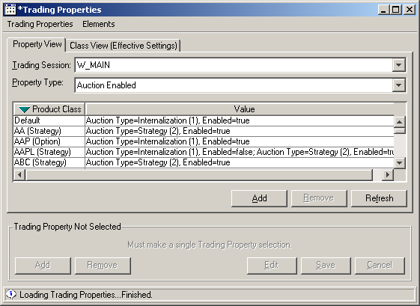
Thus the default value and the value for a class, if set, can be verified.

Verify that the CSV file has been loaded using the SAGUI
If the CSV file is not loaded, the values in the property table will look different from that pictured above. Instead you will see that the auction types in the Value column will be integer values instead of string values, similar to the following window:

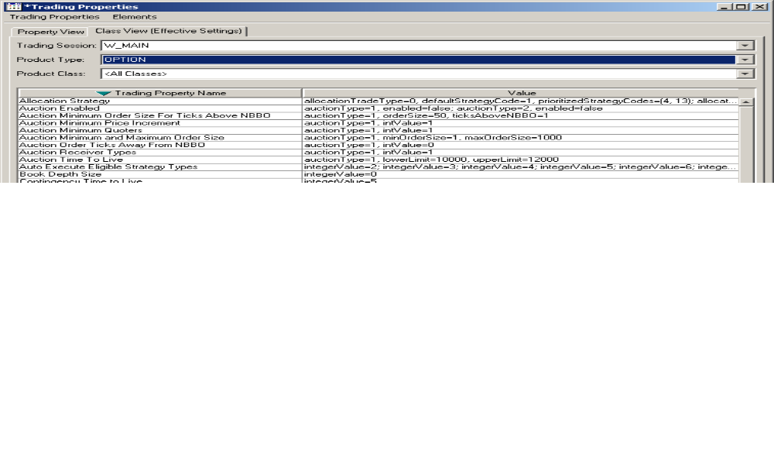

Verify new code in the SAGUI version that is released with HAL
The version of the SAGUI that is released with HAL can be used to verify a fix to a problem previously seen in the behavior of the Trading Properties window:
- Change the default value of any trading property listed above: ensure the Property View tab is selected, select the “Default” product class in the trading property table, click on the “Edit” button, change the value, and click on the “Save” button. Verify the changed value is now seen in the table for the default value.
- Find a class that exists in the session and is NOT listed in the Property View. Since that class does not have a different value assigned to it for the trading property, it should have the default value. Now click on the “Class View” tab and verify that class’s value is now the default value newly assigned in step 1. The problem that is now fixed was that the default value for the class would have been displayed as the old value, before the change in step 1 was made.
- Select the Property View tab, and select any class (not the default). Delete the assigned value to that class. Verify in the “Class View” that the trading property for the class is now the default value set in step 1, and NOT its previous value before the change.

